**BUDGET ANALYSIS AND REMAINDER**

**FIRST INCREMENT**

Submitted By

Sandhya Sannapareddy (16181402)

Raghavendra Chirumamilla (16187866)

Hari charana Kanamarlapudi (16186977)

Sampath Madineni (16185610)

**Import Existing Services/API:** There are no existing services/API or source codes used in this project.

**Detail Design of Services:**

* **User Stories using ScrumDo:**

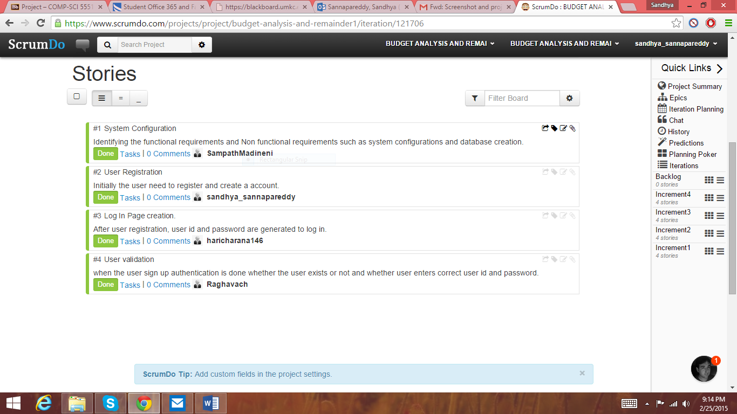

* **Services:**
* Login service
* User Registration
* User validation service
* **Sequence Diagram:**

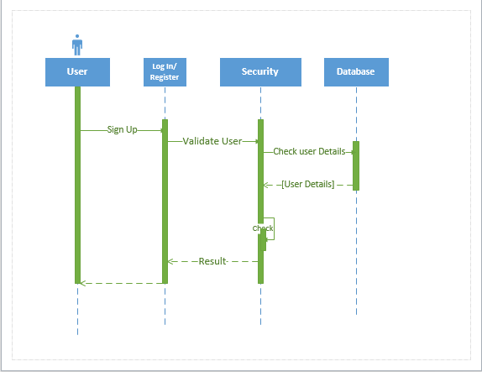

* **Class Diagram:**

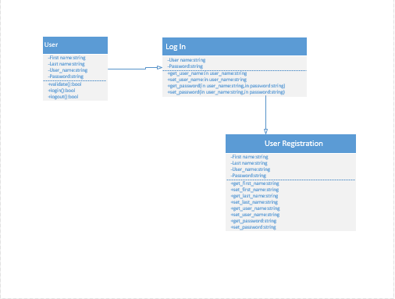

* **Design of Mobile Client Interface**:
* Hardware Requirements:

Dual core processor or 1GHz processor

RAM: 512 MB

SD Card: 50 MB

Device Type: Touch screen with LED screen

* Software Requirements:

Operating System: Android

Version: Gingerbread (2.3) or later

* **Design of test cases:**

**Implementation:**

* **Implementation of user interface:**
* Firstly a welcome screen will be displayed with the App name “ Budget Analysis and Remainder” when we click on the App.



* Second, a login screen with user name and password will appear. If the user is a new user and not hasn’t registered yet then it asks the user to register first.

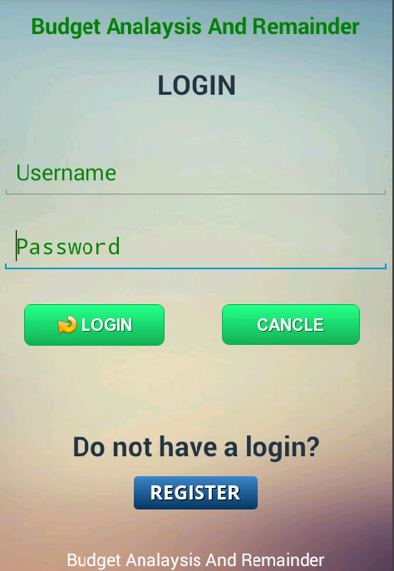

* If the user click on Register button then a new screen appear that helps user to create a new account.

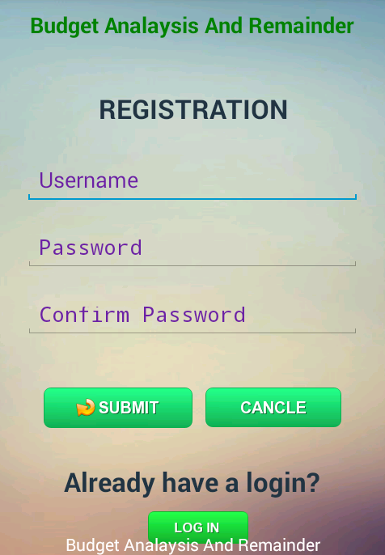

* Next, after registration the user can now login with his/ her username and password and access the services.

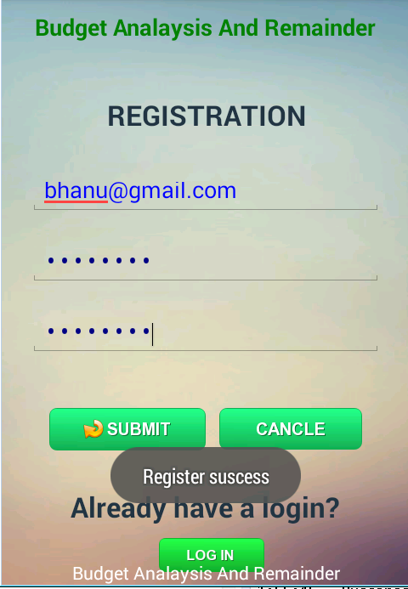

**Implementation of Test cases:**

**Test Case** #1

**System**: Phone

**Subsystem:** Log In

**Pre-Conditions:**

* The user has a valid Access- The user has accessed the account by entering the User Name and password.
* The system displays the main menu.

**Action:** **Expected System Response:**

1. Enter the User Name and password 1)The system displays the login page
2. Press log in 2) The system displays the main menu page.

**Test Case #**2

**System:** Phone

**Subsystem:** Log In

**Pre-conditions:**

* The user has invalid Access-The user doesn’t has access to the account.
* The System Displays the Invalid password.

**Action: Expected System Response:**

1. Enter the different User name and Password 1) The system displays the login page.
2. Press Log IN 2) The system displays again log in page with error notification.

**Testing:**

The test cases are done for Login module and Registration module and observed the following outputs.

* **Positive Test cases:**
* Login Successful: If the user already has an account and during sign up process when user enters correct username and password then a message appear displaying “Login success”

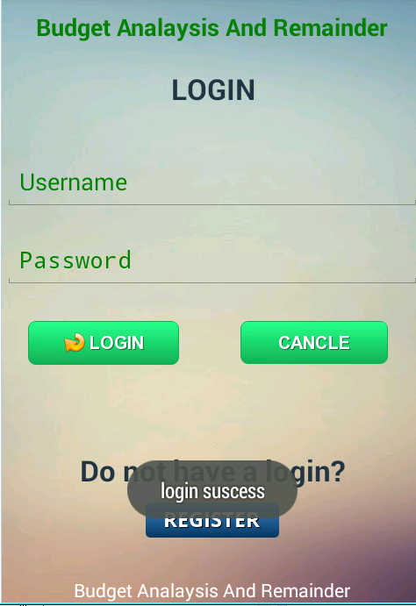

* Registration Successful: In the registration process when the user haven’t registered yet and a new user after providing correct credentials then a message will appear showing “ Registration Success”

**

* **Negative Test cases:**
* Invalid username or password: If the user already exists and during login process if the user enters a incorrect username or password that doesn’t exist or match the existing data records then an error message will displaying “ Enter correct password”

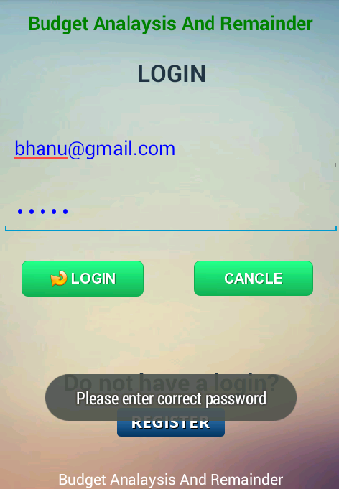

* Invalid Email ID: During the registration process the user needs to enter some credentials like preferred username, password, confirm password and Email ID. If the user enter wrong Email ID that doesn’t exist the a message appear displaying “Enter valid Email ID”

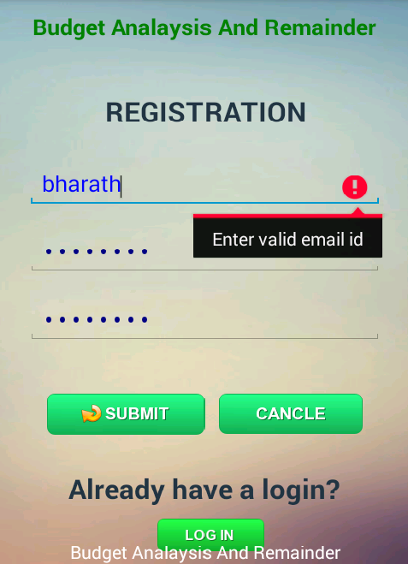

* Password Mismatch: During the user registration the user needs to enter a password and asked to reenter the password in order to confirm that password. When user enters two different passwords then an error message appear with “ Confirm password not matched”

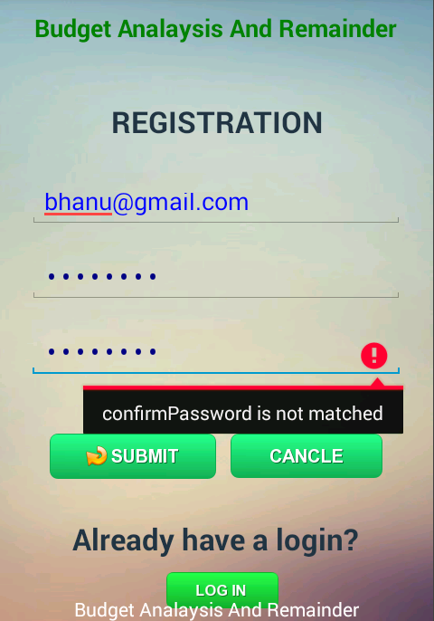

* User already exits: If the user already has an account and when tried to create a new account with same Email ID then error message appear with “ User already exist”

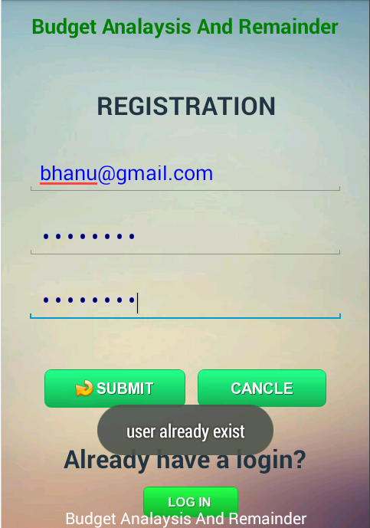

**Deployment:**

* **ScrumDo:**

[**https://www.scrumdo.com/projects/project/budget-analysis-and-remainder1/iteration/121706**](https://www.scrumdo.com/projects/project/budget-analysis-and-remainder1/iteration/121706)

**Project Management:**

* **Implementation status report:**
* **Work completed:**
* Description:

1. System Configuration
2. Login page
3. User registration
4. User Validation

* Responsibilities:

**Sampath Madineni**: Identifying the functional and non-functional requirements of the system and system configurations

**Sandhya Sannapareddy**: User registration. Initially user need to register before signing up

**Hari charana**: After user registration the user need to create a new user id and password

**Raghavendra Chirumamilla**: User validation and database creation. When the user signup the details are added to database and authentication is done whether the user exists or not and whether user enters correct user id and password.

* Time taken **:** 7 days
* Contributions:

Sampath Madineni: 25 %

Sandhya Sannapareddy: 25 %

Hari charana: 25 %

Raghavendra Chirumamilla: 25 %

* **Works to be completed :**
* **Every task was completed by each individual in this team for this increment.**
* **There is no due for this increment.**
* **Issues:**
* System configuration
* Problem during database creation and storing data into database